# MIDDLETON-on-the-WOLDS

# PARISH COUNCIL WELCOME INFORMATION PACK

Now that you have moved into your new home, you will probably find that a few facts about the village, its facilities, and the surrounding area would not go amiss. To help you make contact, a list of telephone numbers is given at the end. The village itself is part of the larger surrounding parish, which is roughly rectangular in shape and extends approximately 1¼ miles from north to south and 5 miles from east to west. The population is approximately 750.

A monthly Newsletter is delivered to every house in the Village once a month. It is a great read and will regularly update village events and discussions.

## Parish Council

This usually has its central meetings in the Village Hall at 7 p.m. on the first Monday of the month (excluding Bank holidays). Notice of these and any Extraordinary Meetings is displayed on the notice board on the village green. All residents are welcome to attend.

Councillors and their contact details are also displayed on the Parish Notice Board and the web site http://www.middletononthewolds.co.uk.

We have a volunteer Green Group and litter pickers (the Womblers) who aim to keep the village looking good. This is a committee of the Parish Council.

## School

Middleton-on-the-Wolds C of E School is situated on Station Road and operates in federation with Beswick & Watton Schools to provide primary education for children from 5 to 11 years. The Pre-School for children from 2½ to 5 years also operates from this building.

MOWSA are Middleton on the Wolds School Association and fundraises to support the school.

The Green group support an after-school club for the mini Green group with the school, working in the polytunnel and planting trees with the children.

## Local Businesses

As you will have noticed, the village has a Post Office supplying daily/national newspapers, greeting cards, and a small amount of sweets and fridges with basic things like milk in case you run out. Prescriptions from the Cranwell Road Driffield Medical Centre can be collected from the Post Office when ordered directly from the Surgery. The delivery service is run by village volunteers who are approved to collect and deliver the medications.

We have a Wold Waves Hair & Beauty Salon on Front Street and a take-Away, Wolds Pizza, on Station Road.

The Robin Hood pub sells alcoholic beverages and serves a range of excellent food. It also has a pool table, offers quiz nights once a month, and has band nights that attract talent from all over the region.

A mobile fish & chip van visits the village on Wednesday evening from 4.40-7.00 pm and parks in the lay-by near the Robin Hood pub.

Mobile butchers (Saturday), fishmongers (Wednesday), and Ringtons Tea (Friday fortnightly) come to the village, and there is a local milkman who delivers milk, eggs, etc, daily.

There is also a small business park on Front Street.

## Places of Worship

St Andrews Church holds Services at least once a month locally and at Bainton Chapel. Details of these can be found in the Middleton Messenger the village newsletter.

## Village Hall & Reading Room

The village hall, built in 1935, is situated on Station Road. It is used for bigger events and could be called on for special uses in the event of an emergency. The venue is available for hire. The Village Hall was recently refurbished and is managed by a committee that usually meets in the Hall at 7.30pm on the second Tuesday in each month. All residents are welcome to attend.

The Reading Room, which opened in 1899 and was used for smaller meetings, is at 7 Front Street. It is currently on a short-term lease to a local business.

# Activities

## Line Dancing

Weekly each Wednesday evening in the Village Hall from 7.30 pm to 9.00 pm.

## Pilates

Weekly each Monday evening in the Village Hall at 5.00 pm. There is currently a waiting list for this event, as the numbers are limited.

## DanceFit

A 50-minute fun, high-intensity, all-over body workout. It is suitable for everyone. Held weekly each Thursday evening in the Village Hall from 6.30 pm to 7.30 pm

## Middleton Movers

Weekly each Thursday afternoon in the Village Hall from 2 pm to 3:30 pm

## Countrywomen

Meets in the Village Hall at 7.30 pm on the third Thursday of the month.

## Book Group

Meets monthly, in the afternoon, in members' houses details published in monthly village

newsletter.

## Middleton Womblers

Litter Picking group meets monthly at Lime View to collect litter from the village. Contact Andrew Naylor at 07825882972

## Middleton Green Group

Formed by friends and neighbours from the village to look after our green spaces, i.e. the village green, beacon field, disused railway line/embankment, including stocking new planters around the town and supporting a mini green group after school club. To join or find out more, please get in touch with Elizabeth Naylor at 07787 483498

## Village Lunch

It is held in the Robin Hood pub at noon once a month. Please get in touch with the pub to arrange it directly.

## YCA

The Young Farmers group meet monthly in the Village Hall.

## Charity Coffee Mornings

It is held monthly in the village hall, offering teas and cakes or sometimes hot sandwiches. It always raises funds for a new charity and is a great get-together for the village.

In addition, car boots, Bingo, quiz nights, elf hunts, Santa drives, and Easter egg hunts are held throughout the year, all arranged by the volunteer groups and in support of the village and/or charities.

# Bowls Club

The Bowls Club has outdoor and indoor facilities on its Market Weighton Road site. It is a small friendly club with opportunities for very committed bowlers and those less committed. New starters are always welcome, and free trial sessions are available at pre-arranged times. For further information ring Penny on 271574.

# Middleton Recreation Club

## Cricket

For age 16 upwards. Thursday nights and Saturday afternoons.

## Football

Age 16 and upwards. The senior team play in the East Riding County League. New players are welcome.

## Tennis

Previously, there was a tennis offering for junior and adult social and playing members. This club was placed on hold in 2023 and if you are interested in resurrecting this please contact the Parish Council. The courts can be rented please contact the Recreation club to discuss directly.

# Contact Details

Bell Ringing Chris Atkin 01377 217285

Book Group Lyn Dennis 01377 219500

Bowls Club Rob Bradley 01377 217435

Countrywomen Christine Johnson 01377 217374

Cricket Dave Newlove 01377 217801

DanceFit Fee 07534 522769

Driffield NHS Dental Access Centre 01377 208360

First Responders Chris Brent 01377 219469

Football Aiden Stephenson 01377 219145

Green Group Elizabeth Naylor 07787 483498

Line Dancing Pat Pottage 01377 217516

Middleton Messenger Village Newsletter Mike Kelly 07713 620912

Lyn Dennis 01377 219500

Middleton Movers Lyn Dennis 01377 219500

Litter Pickers (Womblers) Andrew Naylor 07825 882972

Parish Clerk Catherine Simpson 07597 876724

Pilates Ian Stephenson 07973 755717

Tennis Club Ceased in 2023

Recreation Club Dave Newlove 01377 217801

St Andrews Church Rev Jane Anderon 01377 219471

St Andrews Church Wardens Chris Brent 07766 162743

Lesley Kelly 07907 451046

Village Hall Sharon Roe 01377 217254

Village History Geoff Wisher 01377 217517

# Mobile Library

This visits the village fortnightly on Tuesdays and parks at the lay-by in South Street from 9.25am to 10.30 am and outside the school from 11.45 am to 12 noon.

# County Council

Middleton is within the East Riding of Yorkshire Council, headquartered at County Hall, Beverley, with Customer Service Centres in Driffield and Beverley and other towns.

Each year, the Council produces a comprehensive guide to its services, which also lists its elected representatives, and this is delivered to each household as a monthly newsletter with further information about new developments. It should be pointed out that the area of the present East Riding differs from that of the historic pre-1974 county.

# Waste Collection

Each household is provided with three wheelie bins. The council website offers an app that will send you a reminder, The bins supplied are for use with:

*Green:* a fortnightly collection of household waste on Friday or Saturday if the previous Monday was a Bank Holiday.

*Blue:* a fortnightly collection of paper and other recyclable items (Friday).

*Brown:* a collection of garden waste fortnightly in summer and monthly in winter (Wednesday).

The Council produces and sends an annual sheet outlining the collection dates, delivered directly to each household once a year. They also supply a waste refuse ticket that must be taken by each car when attending the local tip. Failure to do so can led to you being asked to leave without them taking your waste.

# Buses

The bus service to Beverley is minimal, but the service to Driffield is far more frequent.

Service 743 Driffield, Middleton, Pocklington

Service 142 Middleton to Driffield

Middleton to Beverley

For timetable details, please ring 01482 222222.

Driffield School and Wilberforce, Wkye and Bishop Burton College buses will attend the village but are arranged directly between the pupils and the education provider.

# Neighbouring Towns

We are centrally placed between our neighbouring towns, all approximately 8-miles from Middleton on the Wolds.

Pocklington Market Day Tuesday

Driffield Market Day Thursday

Beverley Market Days Wednesday and Saturday

Market Weighton

# Medical and Dental Facilities

## Hospitals

The following have 24-hour Accident & Emergency Facilities)

1. Hull Royal Infirmary NHS Trust
2. Scarborough & District Hospital NHS Trust

There is also a Minor A & E at

1. Alfred Bean Hospital on Bridlington Road, Driffield YO25 5JR
2. East Riding Community Hospital, Swinemoor Lane, Beverley HU17 0FA

There are Medical Centres in Cranwell Road and Bridge Street Driffield. (For out-of-hours emergency service, contact NHS Direct at 111.) There is an arrangement with the Post Office in Middleton for medication to be collected from the Cranwell Road Medical Centre and brought to the Post Office for collection.

## Dentists

Please get in touch with East Riding of Yorkshire Clinical Commissioning Group Trust on 01482 650700 for details. Or 111 if urgent care is required.

## First Responders

There exists within an active village group, and are all trained defibrillator users in the village on-call via the Ambulance Service which always needs new volunteers.

The defibrillator is located external to the Village Hall.

## For emergency/major incidents

The Village Hall can be opened to deal with Emergency or Major Incidents. The following are Key Holders and can be contacted if required:

Dave Pratt 01377 217453

Kath Bentley 01377 217456

Marie Fox 01377 217285

# Local Events

On the third Wednesday in July there is the annual Driffield Show which is held on the Kelleythorpe Show Ground Driffield.

On the third Thursday in March there is the annual Kiplingcotes Derby.

On the first Saturday each month the Driffield Farmers’ Market is held at the Kelleythorpe Show Ground, Driffield.

Middleton on the Wolds also hold a Village Show once a year in the Village Hall during July. Programmes are delivered to each household in the Village which gives all entry classes etc. Everyone is welcome to take part.

# Village History

The attached sheet lists 12 significant facts about the evolution of the village.

In connection with the general history of the area the Treasure House in Beverley contains much documentary information about the pre-1974 East Riding together with visual displays. There is also a similar facility in Hull.

## History Of Middleton-On-The-Wolds : Some Highlights

1 “Middleton Parish is rich in archaeological remains that date from the pre-historic onwards and which include linear crop marks, enclosures, Iron Age square barrow cemeteries and later features” so an archaeological report states.

2 There was a settlement before the Norman Conquest as a church with a priest is referred to in the Domesday Book.

3 Before the Conquest there were four landowners and by 1087 this had been reduced to two. Over the years landowners have included Archbishop Ealdaed, Robert de Mortain, the Earls of Burlington, the Duke of Devonshire, George Hudson (briefly, before his public disgrace) and Lord Londesborough. Following the agricultural depression which began in the 1870s farms started to be sold off.

4 The present church was commenced about 1280 (chancel) and the nave completed about 1360. A tower was added in 1830 and the whole building substantially restored in 1873.

5 The present Robin Hood car park is the site of the ancient Manor House Farm which was also the venue for meetings of the Manorial Court.

6 The original rectory was next to the church. This was demolished in 1809 and a new house was built on the estate behind the wall on the Beverley Road. This was eventually sold to Captain Brooksbank (later Colonel) and became known as `The Hall` (demolished about 1960). Another rectory was build in 1867 (off Church Hill) and in 1947 the now privately owned house known as `Warter Lodge` in Warter Road was used as a rectory.

7 Enclosure of land took place 1803-5 and as a result the present layout of farms and buildings was established. The Rector became a substantial landowner.

8 Wesleyan Methodist chapels were built in the village – Chapel Lane built 1809 and closed 1902 when the present chapel in Front Street opened. The Primitive Methodist Chapel in Station Road built 1864 closed in 1932 and is now private dwellings.

9 The Reading Room was opened in 1899.

10 The Village Hall opened in 1935.

11 The old school in Front Street, now dwellings, was built in 1872 and closed in 1968 when the new school in Station Road opened.

12 The pond originally reached the roadside. In 1953 the side near the road was grassed and three seats provided.

July 2008

# Useful Links for the Village

## Parish Council

http://www.middletononthewolds.co.uk

## Village Hall

Facebook Page

## Middleton Recreation Club

Facebook page

## School

Middleton-on-the-Wolds C of E

## Middleton on the Wold's area selling site

Facebook page

## Post Office

Offocail opening times

## Wolds Waves Hair & Beauty Salon

Facebook page

## Wolds Pizza Takeaway

Menu page

## Pothole reporting

<https://www.eastriding.gov.uk/environment/roads-streets-traffic-and-parking/>



## [Trees, hedges and grass cutting](https://www.eastriding.gov.uk/environment/tree-hedge-and-grass-cutting/)

https://www.eastriding.gov.uk/environment/tree-hedge-and-grass-cutting/

## Fly Tipping reporting



## Railway and Embankment History

Youtube historian.

## St Andrew Church

https://www.achurchnearyou.com/church/19113/

## Robin Hood Inn

<https://therobinhoodinnmiddleton.com/>

## Black Yak

https://www.blackyak.co.uk/

# Litter bin location around our village

Middleton has a wonderful community spirit. We look out for our friends and families and help one another where we can. Here in Middleton, you are never far from a waste bin – in fact there are 10 around the village for you to use. Please view the map for details.

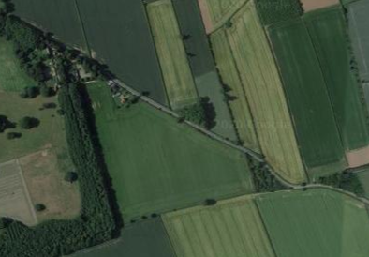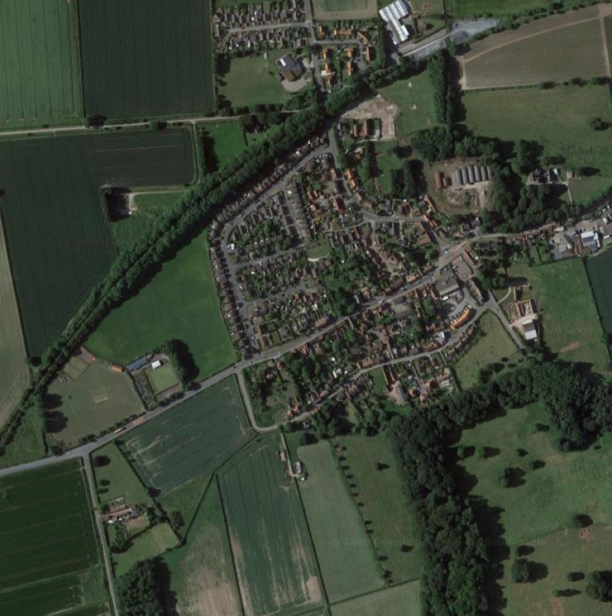

**Key to the Map:**

**Where the waste bins located in Middleton on the Wolds:**

1: Outside the School

2: Warter Road, bottom of the steps leading to the railway line

3: At the entrance to the Playing Fields

4: At the top of Mill Trod, on Goodmanham Road

5: At the bottom of Mill Trod, on the corner of South Street

6: By the parking space by the Cemetery

7: By the young children’s play area, Orchard Drive

8: By the village pond

9: By the village hall on Station Road

10: Large green bin by the footpath entrance/parking space on Beverley Road

# Walks around the Village

Note that The permissive path must not be opened up to the highway A614

