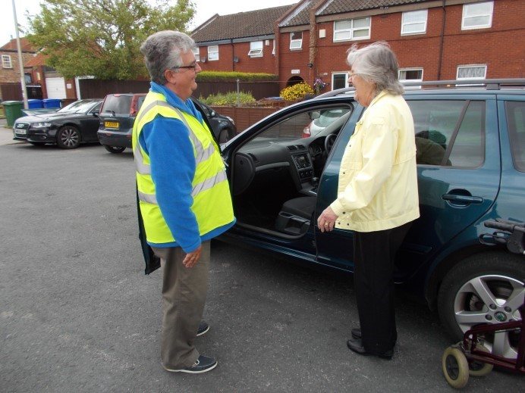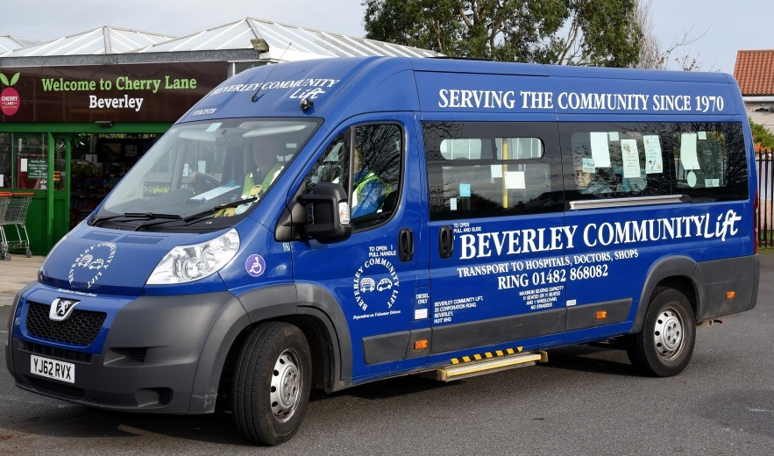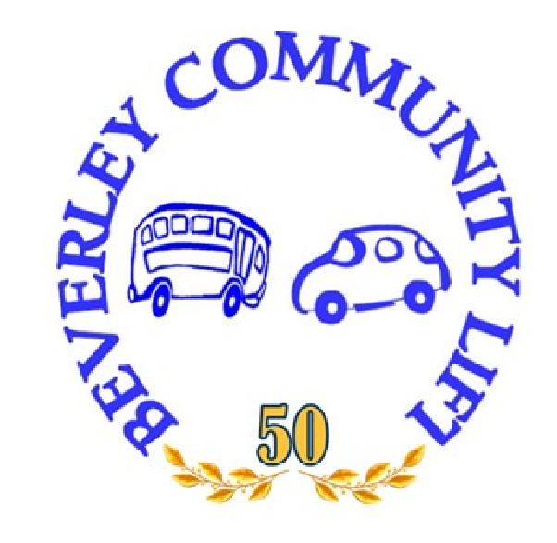

Reg. No. 1163868

Beverley Community Lift (BCL), the community transport operator for Beverley, Cottingham, Market Weighton and Pocklington, celebrates 50 years of serving East Yorkshire in 2020.
We have an unrivalled track record of helping thousands of residents across the county who have difficulties using public transport or no access to cars.
Could you be part of this success story and help continue the great work of volunteers into the next half-century?

Car Scheme Drivers
Drivers use their own car to provide essential door-to-door transport for passengers who have registered with us.
You could be asked to help passengers into or out of the car and are expected to wait with those attending a medical appointment, for up to an hour.
Put your driving skills to good use and we will pay up to 40p a mile.
We are looking for drivers over 25 with a full licence and no more than six penalty points.

Minibus Drivers
Beverley Community Lift operates shopper services to various East Riding towns and day trips for its clients to places like York, the coast and other popular destinations.
We need more drivers in Beverley, Cottingham, Market Weighton and Pocklington - no minibus experience is necessary as full training will be given.
Volunteers need to be 25 or over and have a D1 driving licence.
If you have great communication skills, good time-keeping and enjoy helping make someone’s day, then please talk to us.

Passenger Assistants
Our minibus drivers often enjoy the support of a volunteer to help with journeys and looking after our passengers. We run regular shopper services and day trips so it is up to you how much time you can give. The role may involve assisting customers with wheelchairs and handling money.
What to do next: Contact us on 01482 868082, email manager@bclift.org.uk or find out more about us at www.bclift.org.uk.

Be part of our success story
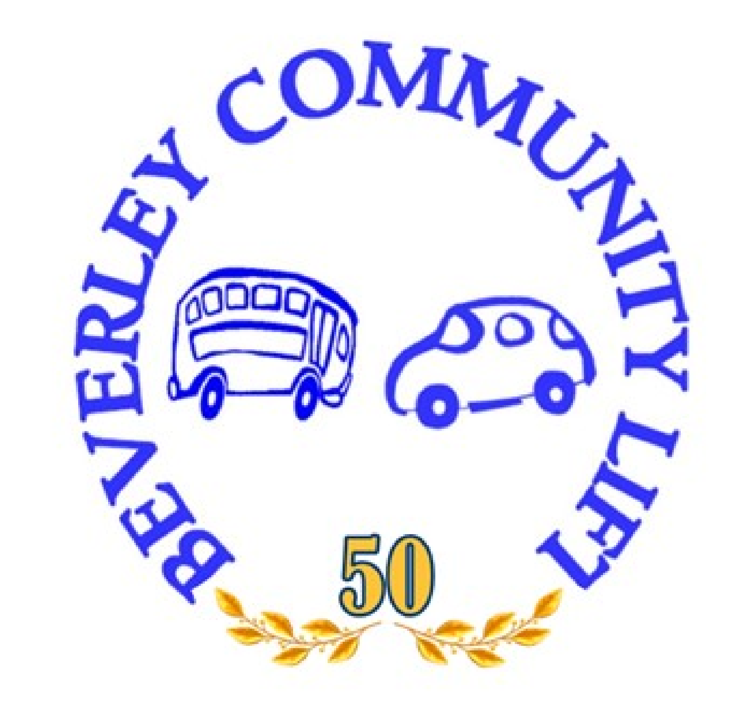
Reg. No. 1163868
Serving East Yorkshire since 1970

