CONSERVATION AREA APPRAISAL

MIDDLETON ON THE
WOLDS

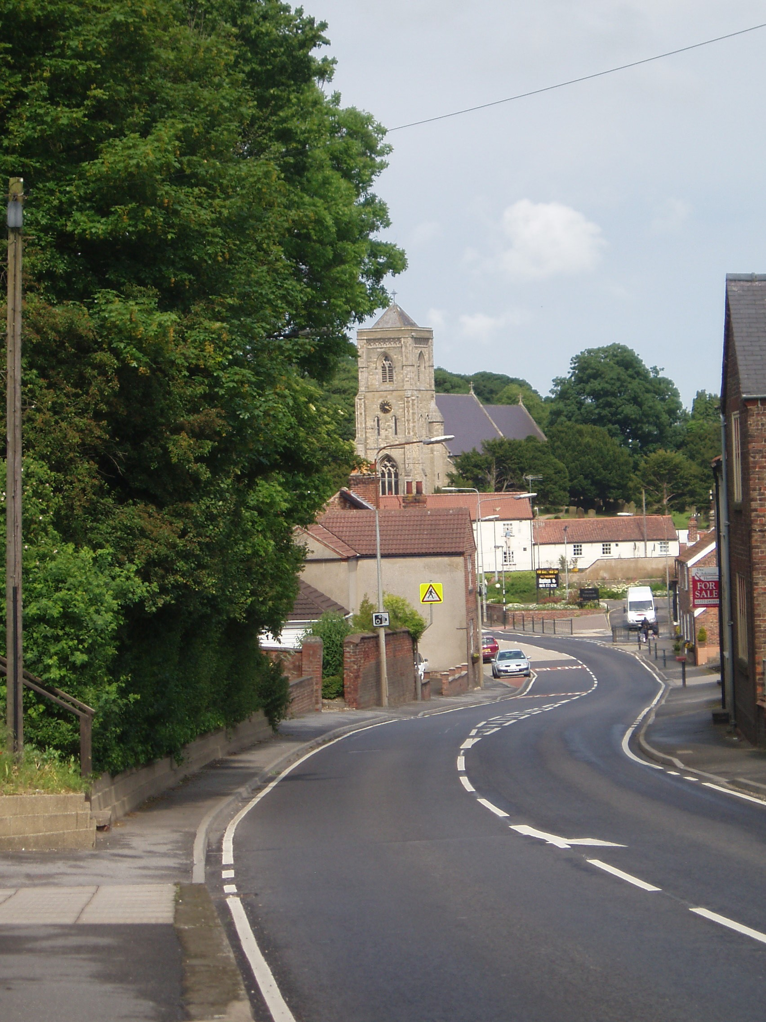

EAST RIDING OF YORKSHIRE COUNCIL

2011

MIDDLETON ON THE WOLDS

CONSERVATION AREA APPRAISAL

INTRODUCTION

The National Situation

The concept of Conservation Areas was established over 40 years ago in the 1967 Civic Amenities Act. This enables the importance of areas rather than individual buildings to be recognised.

The Town & Country Planning Act 1990 defines a Conservation Area as “an area of special architectural or historical interest the character or appearance of which it is desirable to preserve or enhance”.

For the designation of Conservation Areas to be effective, it is important that rational and consistent judgements are made in determining their special qualities and local distinctiveness, as well as their value to the local community. Such judgements should be based on a thorough understanding of the area in its wider context, reached through a detailed appraisal of its character.

The purpose behind Conservation Area designation is not to prevent any further change; rather it is to ensure that whatever change does occur is carefully managed. In the past forty years, in England, over 9500 Conservation Areas have been designated by local authorities.

The Local Situation

The Conservation Area for Middleton on the Wolds was first considered for designation by officers of the East Riding of Yorkshire Council in 1997.

At that time resources were mainly concentrated on the designation of over a dozen new Conservation Areas that the former Beverley Borough had appraised, but which remained uncompleted when the East Riding Council came into being in 1996.

In 2005 National Government required that local authorities should have up-todate appraisals of all their Conservation Areas, and in the last four years precedence has been given to this work, so that by the end of 2011, all East Riding Conservation Areas (of which there are currently more than one hundred), should meet that requirement.

Time was then made available for the consideration of additional Conservation Areas, and although most locations that had the criteria for designation had already been identified and designated, there were still a handful of settlements which it was considered would benefit from the status and additional protection that designation would provide.

Middleton on the Wolds was one of these, and so an approach was made to the Parish Council early in 2009 asking for their support in principle of a designation.

Following a discussion with them, this was agreed, and this appraisal was the result of it. It describes the village’s character and appearance, its history, and how the Area can be protected to preserve its specialness. This was then made available to Middleton’s residents, who had the opportunity to make their comments known as part of the consultation process and these were taken into account before any decision on designation was made.

The appraisal has been undertaken in accordance with “Guidance on
Conservation Areas” issued by English Heritage in August 2005 in order to meet the current requirements of national government for such designations.

Within the parish there are four listed buildings, three of which come within the Conservation Area.

The Conservation Area includes over 120 properties which collectively were considered to represent the historic core of the village.

It should be noted that this appraisal makes reference to features that are beyond the boundaries of the Conservation Area, where these may have (or have had) an impact on it.

THE CHARACTER AND APPEARANCE OF THE
CONSERVATION AREA IN
MIDDLETON ON THE WOLDS

This document identifies the special architectural and historic interest of the character and appearance of Middleton on the Wolds. It indicates how this should be preserved and enhanced and will be useful to potential developers, residents and businesses and to the Council in the making of Development Control decisions and environmental improvements.
DEFINITION OF
MIDDLETON ON THE WOLD’S SPECIAL
INTEREST

The character and appearance of the village of Middleton on the Wolds is dominated by two features:

St. Andrew’s Church, which benefits in this respect from its elevated position, and secondly the main road, the A163, which imposes itself because of its near continuous parade of traffic including many heavy goods vehicles during the major part of most days.
For this reason it is possible to forget that Front Street is part of a village, yet one does not have to go far beyond this for the green village character to re-establish itself.

Travelling westwards, the rise from the mini-roundabout near the Robin Hood Inn to the junction with South Street is unusual amongst East Yorkshire villages, which are often built on level ground or, at best, with only some slight elevation.

The contrast between Front Street & South Street is profound, and marked by the urban character of the former, compared with the rural qualities of the latter.

a) Topography and its Relevance

The Middleton on the Wolds
Conservation Area lies within the ‘North Wolds Plateau Farmland’ Character Area, as identified in the East Riding of Yorkshire Landscape Character Assessment (ERYC, 2005). The Landscape Character Assessment notes that this area includes the northern extent of the Wolds dip slope.

There are several villages dispersed across this character area and whilst these are distinctive in their own right, their relationship with the surrounding open rolling farmland contributes to the distinctiveness of this landscape area as a whole. Archaeological interest is also present, notably at Danes Graves which would have originally consisted of 500 small barrows and is the site of an Iron Age cemetery, and also at Pockthorpe Hall which stands on the site of a deserted medieval village.

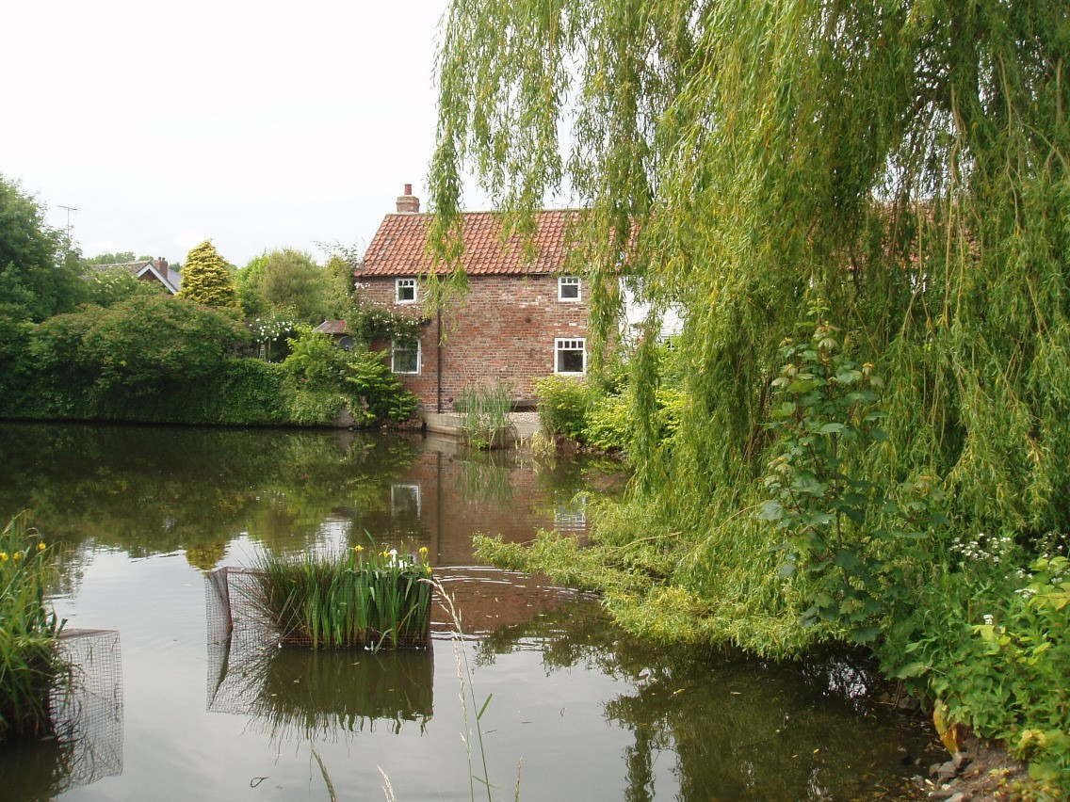
The Village Pond

This landscape includes many isolated farmsteads which are typically positioned in elevated locations that offer extensive views of the surrounding agricultural land which was shaped by, and still shows signs of, the Parliamentary Enclosure period. Many of the farm holdings are relatively large in scale and often include dominant landscape features such as grain silos which are distinctive on the skyline. As a consequence, farmsteads tend to be a prominent feature. The area has relatively little woodland, other than that found as shelterbelts around farmsteads and settlements.

Also characteristic of this Wolds landscape is the network of wide roadside verges, many of which support a variety of chalk grassland species such as salad burnet, wild thyme and common rockrose. Also, disused railway lines, for example at nearby Enthorpe Cutting, provide valuable habitat for calcicolous plant species which may otherwise be scarce, such as long-stalked crane’s bill, fragrant orchid, rue-leaved saxifrage and red valerian.

b) The Natural Environment

Whilst the Middleton on the Wolds Conservation Area is located within a landscape largely dominated by intensive arable land-use, the village itself contains a variety of areas of natural environment interest. Although there are no statutorily designated wildlife sites close to the village, there are a number of locally important ones, such as the area of geological interest at Middleton Chalk Pit and the roadside verge along Warter Road. Whilst such wildlife-rich areas are generally fragmented and isolated, large areas of agricultural land to the northwest, southwest, east and southeast of the village are currently under Environmental Stewardship schemes which help to enhance the wider local landscape.

Within the Conservation Area itself, an important characteristic is the relationship between the settlement’s built form, small areas of enclosed open space and views of the wider open landscape from within. There is a notable lack of publicly accessible open space in the village, but this is perhaps a reflection of the rich open spaces surrounding it which serve this purpose.

More details of these can be found under section (d) of this appraisal.

In addition to the well-maintained open spaces, there are a number of more natural areas. Examples of these are the churchyard with its unimproved grassland and trees, including a large stock of mature yew, and the parish pond which, although lacking significant marginal land around it, provides valuable aquatic habitat in the area.

There are also some valuable areas of enclosed agricultural land present either within, or directly adjacent to, the Conservation Area, for example the land to the south and west of Pigeon Cote Farm and that to the south of South Street – such areas provide valuable views out of the Conservation Area into the surrounding rural landscape.

The area of land comprising the modern cemetery and the agricultural enclosure to the southwest of the junction of Beverley Road and South Street form a valuable asset. This area is important in terms of offering valuable views southwards out of the Conservation Area to the adjacent agricultural landscape and wooded slopes, forms a key component in the village-wide context of small agricultural
enclosures and also in securing the attractive, rural nature of this edge of the village when approached from the southeast.

Many of the dwellings in the village are served by medium-sized gardens and these not only contain standard trees that contribute greatly to the wider character of the area, but also add to an enhanced diversity of wildlife. Some of the boundaries within the village remain as traditional native hedgerows, many of which have been assimilated successfully into forming domestic curtilages. Native hedgerows in the area, including species such as hawthorn, blackthorn, dog rose and elder, provide a valuable element of the quality of the Conservation Area and where they are complimented by grass verges, these add to the rural character of the village.

All of the linear natural features – be they hedgerows, verges etc - help to link the natural features within the Conservation Area, such as the small parcels of open space, to those areas of wildlife interest outside it and these should therefore be conserved and enhanced wherever possible.

c) Tree Preservation Orders

As trees nearly always contribute positively to the character and appearance of a Conservation Area, they are protected from unnecessary felling or pruning.
Therefore all significant works to trees in
Conservation Areas need prior notification to be given to the Local Planning Authority.

If it is decided that the tree is worthy of additional protection, a Tree Preservation Order can be made.

In the case of Middleton on the Wolds, there is only one confirmed Tree Preservation Order, which was made in 1989 and relates to trees in the grounds of Parklands Hall, just within the boundary of the Conservation Area at its north-east corner.

d) Open Spaces
Public open spaces of interest include the small green and parish pond with its amenity grass and trees, the intermittent roadside verges and grassed areas along Main Street and the western end of South Street and the cemetery to the southeast corner of the Conservation Area. Such features serve to ‘punctuate’ the built form of the village.

There are also a number of areas of private green open space scattered throughout the village. These often provide the location for mature trees which, although not particularly dominant in Middleton on the Wold’s streetscape, nevertheless provide a valuable resource with species such as ash, lime and sycamore often foremost. The grounds to Parklands Hall are a fine example of how mature trees can contribute to a settlement’s streetscape and these specifically provide a vital component at the principal eastern entrance to the village. Species such as ash, lime, Scots Pine and sycamore are present here.

However, within the Conservation Area as a whole there are few significant public open spaces. This is partly due to the fact that a good proportion of the village’s properties are at back-of-pavement-edge.
That is what makes the churchyard, the wide verges at the north end of South Street, and the village pond particularly important as a balance to the otherwise hard landscaping.

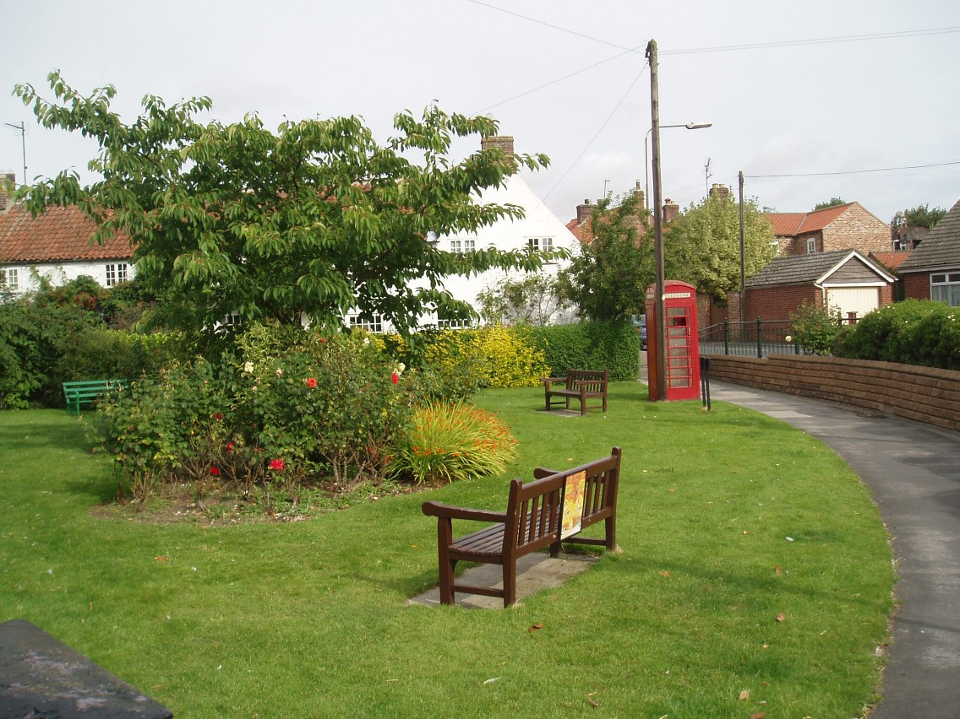
Public Amenity Space in the heart of the Village

- Boundary Treatment

There are a variety of boundary treatments throughout the length of the village.

First there are properties which are at back-of-pavement-edge, which have no separate boundaries. Second there are properties which are only nominally set back from the pavement, some of which have dwarf walls or small plantings, which help to soften the streetscape.

Elsewhere, hedges of which the most prevalent varieties are hawthorn (or privet) succeed in adding to the streetscape’s mixed nature.

- Origins and Evolution

The place-name Middleton is Old English in origin, and means “middle farm”. It was first recorded at the Domesday survey in 1086 and shows that the village was a pre-conquest foundation. Information from the 11th century suggests that a sizeable settlement existed here at the time of the Norman Conquest and that there were two major landholders, the Archbishop of York and the Count of Mortain. Domesday records that there were at least 12 men including a priest here. In 1377 the Poll Tax returns shows that Middleton was still a substantial settlement yet despite its size and wealth it never gained the distinction of hosting a market or fair. A Church is recorded here at 1086 although the present structure mostly dates from the 19th century.

The development of the village – apart from its convenient location in a sheltered valley – doubtless evolved from its position as one where no less than six roads meet. This gave ready access to Driffield, Market Weighton & Beverley, and further afield to Bridlington, Hull and York. Geographically it is perhaps the most central settlement in the East Riding.

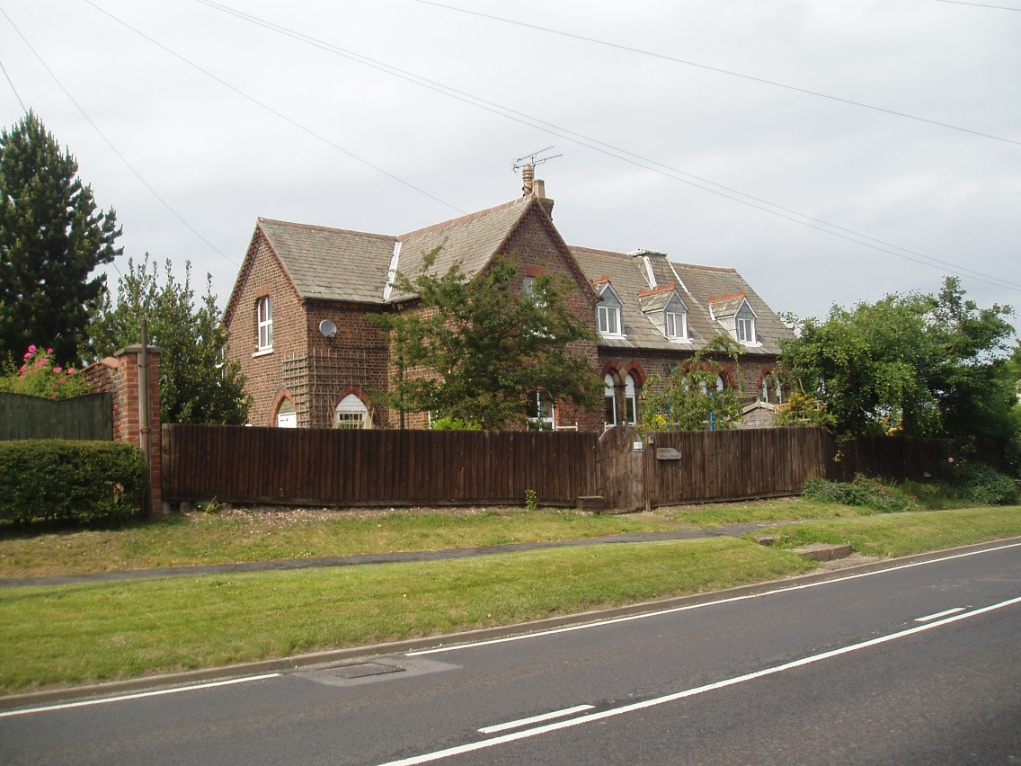
The Old School

Historically the manor, with a large estate of land, was held by the Boyle family, Earls of Burlington, from whom it passed through marriage to the Duke of
Devonshire. It was then purchased by an ancestor of the Earl of Londesborough, who lived at Londesborough Park, some five miles to the south west of the village.

Following the enclosure of the open fields of the village in 1805, seven new farmsteads were established in lands that formerly belonged to those fields, away from the village itself.

A windmill mound stood at the northeastern end of the village on the south side of Church Hill Road but this is not
shown as being in use on the 1775 Jeffreys Map, one of the first detailed depictions of the village’s layout.

In common with other East Riding villages, Middleton on the Wolds felt the influence of nonconformity in the 19th century, which led to the building of no less than five chapels between 1809 and 1902. Three of these were Wesleyan, and two Primitive. Only one, the youngest, still survives in use, the others having either been demolished or converted into houss.

The growing importance of education during the Victorian era is shown in the building of a National School in the village in 1872, at a cost of £972. It accommodated over 100 children. Since closure this has been converted into a house, but still retains several of its original features.

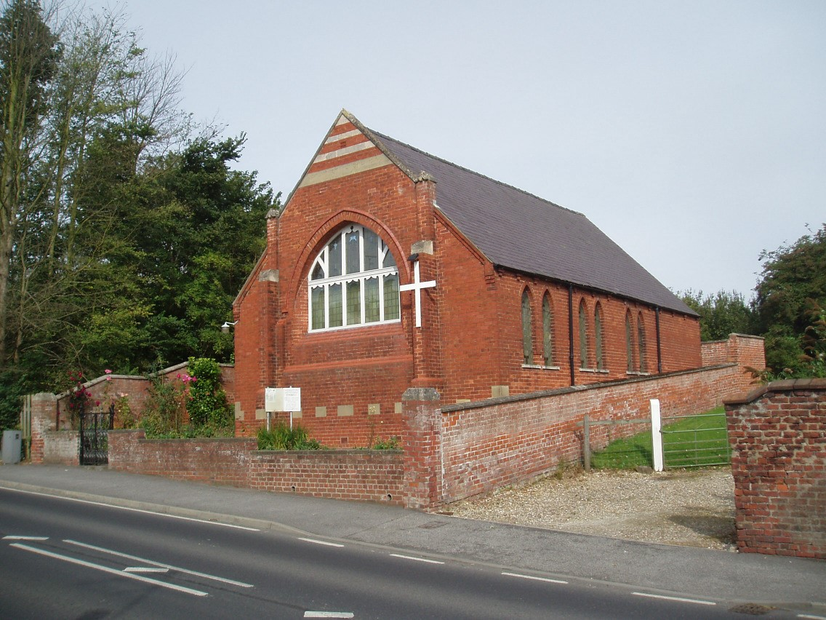
Middleton Methodist Chapel

In the late 19th century, the status of the village was given a boost by the arrival of the new Driffield to Market Weighton railway line which skirted the village on its north side and whose station offered connections to Selby as well as to York and Hull.

The line closed in the 1950’s by which time from the commercial point of view, road transport offered a more flexible and less expensive option.

The increased use of the car has also been responsible for the change in the character of the village. Whereas a century ago, Middleton was being described as “wholly agricultural”, its pleasant setting and central location has resulted in its more recent development to include homes for families working away from the village, in non-agricultural jobs, and who commute daily to locations further afield.

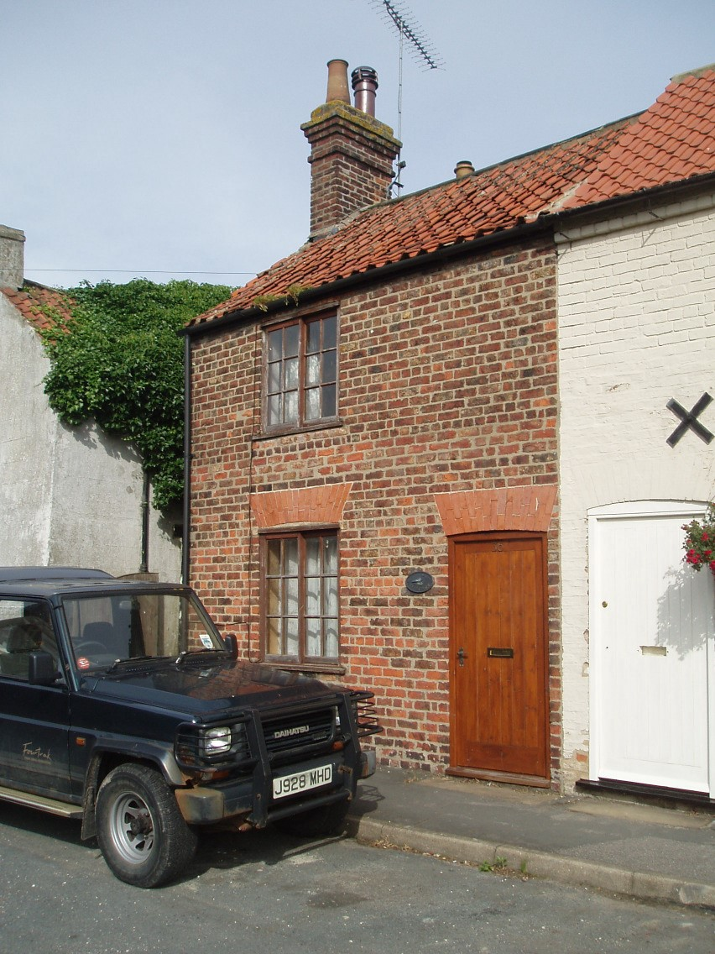
A typical historic cottage, still retaining many authentic features

As a result of this the village’s population, which had steadily declined between 1901 and 1961 from 634 to 494 has since increased (to 774 in 2001).

By comparison, curiously, during this period of population decline, the number of households increased, from 154 (1881) to 174 (1961).

g) Archaeology

In common with many of its neighbouring Wolds Parishes, the earliest human activity is likely to have been that of Mesolithic hunter-gatherer groups, followed by the first evidence of settlement appearing in the Neolithic era.

However, it is with the onset of the Bronze Age that the first settlement activity becomes obvious not only within the Parish, but also within the village itself. Three discrete Early Bronze Age burials were discovered separately on the north side of Front Street in 1901-2 and 1905, when digging for sand.

Iron Age activity in the village is thought to be represented by the ditches of an early field system identified during trial excavations at Station Farm in 2002.

Roman pottery was recovered from several of these trenches in the same year and a Romano-British burial was found at a chalk quarry just north of the village school in 1921.

The Old English background of its place name confirms that Middleton continued through the Dark Ages, to reappear in the Domesday Book almost a millennium later.

h) Layout and Disposition

The 1775 Jeffreys Map shows Middleton as a sizeable settlement which had developed around a major crossroads. However, the village layout may well be a creation of the post Medieval period and the layout of the village crofts suggests that the older tenements line the south side of Front Street and that the original more important access was along the north-east – south-west route of Front Street and Church Hill Road with the village Church and the Manor House lying on either side of what is now the northern end of Beverley Road. The majority of the plots between Front Street and South Street still retain the narrow strip pattern of the medieval crofts.

The great majority of East Riding villages have their properties facing the roads which front them. In this, Middleton follows the trend though there are one or two houses that show their gables to the road. This adds to variety and interest and forms part of the special character of the Area.

Although the buildings are predominately detached, the space between them is adequate rather than generous, which adds to the general feeling of cohesion and integrity.

Mention has already been made under ‘Boundary Treatment’ of the siting of properties relative to the road, with those in the middle of the village often being at back of pavement edge. More recent additions tend to be set further back, which has the benefit that in views along Front Street they are less prominent in the streetscape, allowing precedence to older properties so giving more of a ‘historic’ view.

j) Buildings

The oldest building in the village is the church, St. Andrew’s, though this statement needs qualification, as parts, including the tower, the north wall of the nave and the south porch were rebuilt by J M Teale of Doncaster in 1873-4, incorporating old masonry.

Also classed as ‘buildings’, technically, because they stand on their own, are four listed tombstones in the churchyard. These are believed to date from the 13th century. Three of them bear incised crosses, and the fourth, which rests on small pillars of more recent date, has the figure of a man carved on it.

Parklands Hall, the former rectory, stands opposite and dates from 1867. It is in the Victorian Gothic style, which was doubtless felt to be appropriate to its use. Before this, Horsewold Farm was built (c.1810) for the Rector, probably by Peter Atkinson, junior, of York, who the previous year had designed a new rectory house, half a mile south east of the church. This building became Middleton Hall of which only part of the stable block now remains.

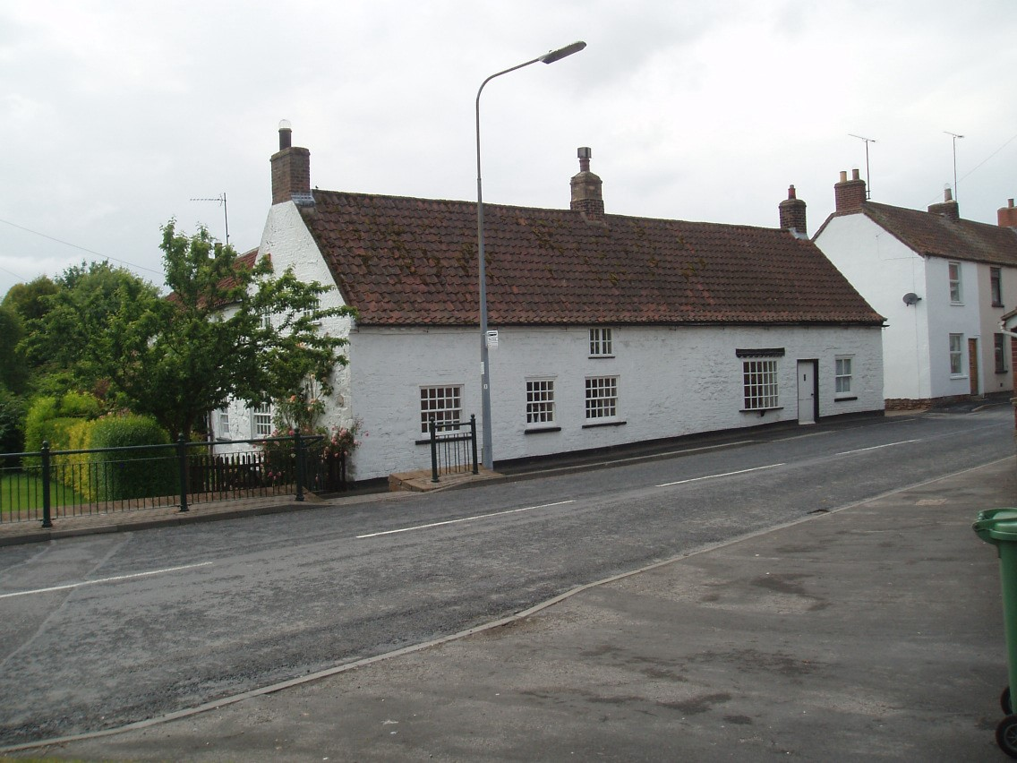
Quackers Cottage, (Grade II listed)

The only listed residence in the village is Quackers, (appropriately) adjoining the pond. The cottage has been formed out of a block of single storey chalk stone cottages, dating from the 18th century, but remodelled in the early 19th century.

A look at the 1886 OS Map of the heart of the village shows that, although the basic road layout is little changed, the buildings and the buildings’ usage are in may instances very different. Gone are the sites of the Manor House, the sand pit and the smithy, and the retail outlet (former Stratstone site) imposes a significant presence in a very sensitive location.

Further reference to this site is made under “New Developments,” on page 13.

- Scale

The great majority of the historic buildings in the village are of two storeys, but not exclusively so, as the single storey listed ‘Quackers’ shows. In total there are just a handful of single storey bungalows and cottages.

Although there may be some uniformity in the number of storeys, there are significant differences in the heights of individual houses, which once again helps to add character to the streetscape.

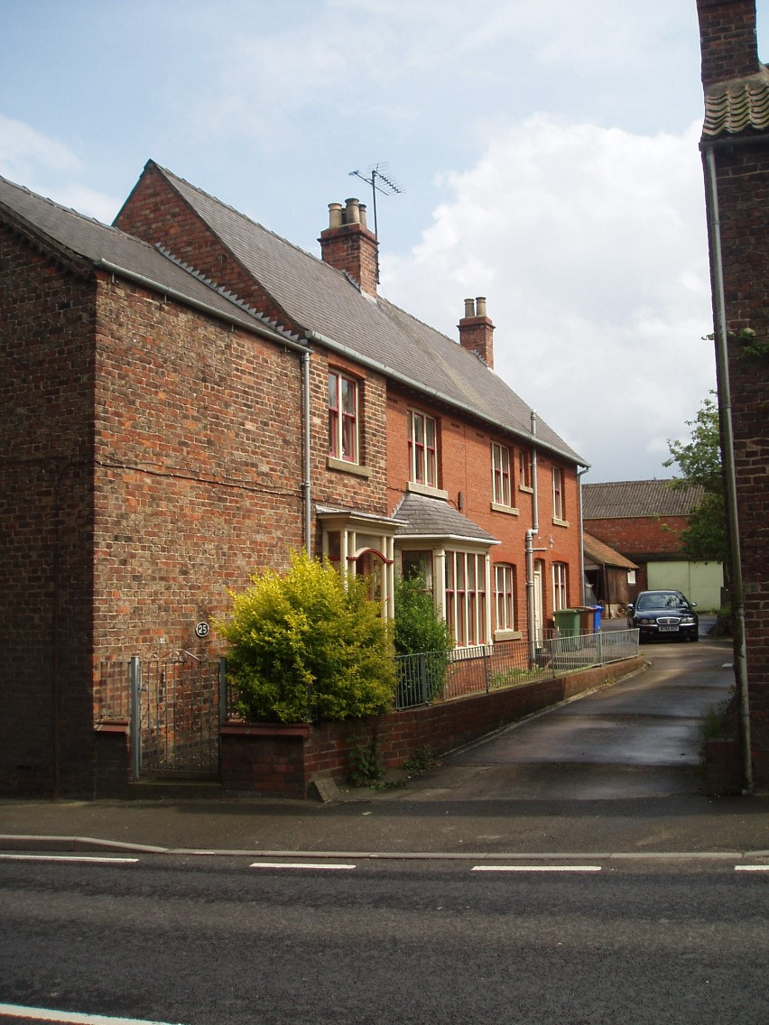
No 25 & 27 Front Street – two of the village’s side facing properties

- Orientation

As mentioned under section (h), nearly all of the properties in the Conservation Area face onto the roads which front them, though a few are with gable end to the road and door(s) to the side, perhaps to maximise a narrow site?

- Materials

In the East Riding, the use of building materials normally reflects what would have been available locally at the time as, historically, heavy materials were only transported over long distances for expensive, high status buildings, such as its churches.

The situation only changed with the improvement of communication links which in Middleton’s case means the arrival of the railway, following the building of the Driffield – Selby line and the opening of a station just to the north of the village, in 1890.

It was not until the motorisation of road transport – ie. in the twentieth century - that products could be delivered from almost anywhere.

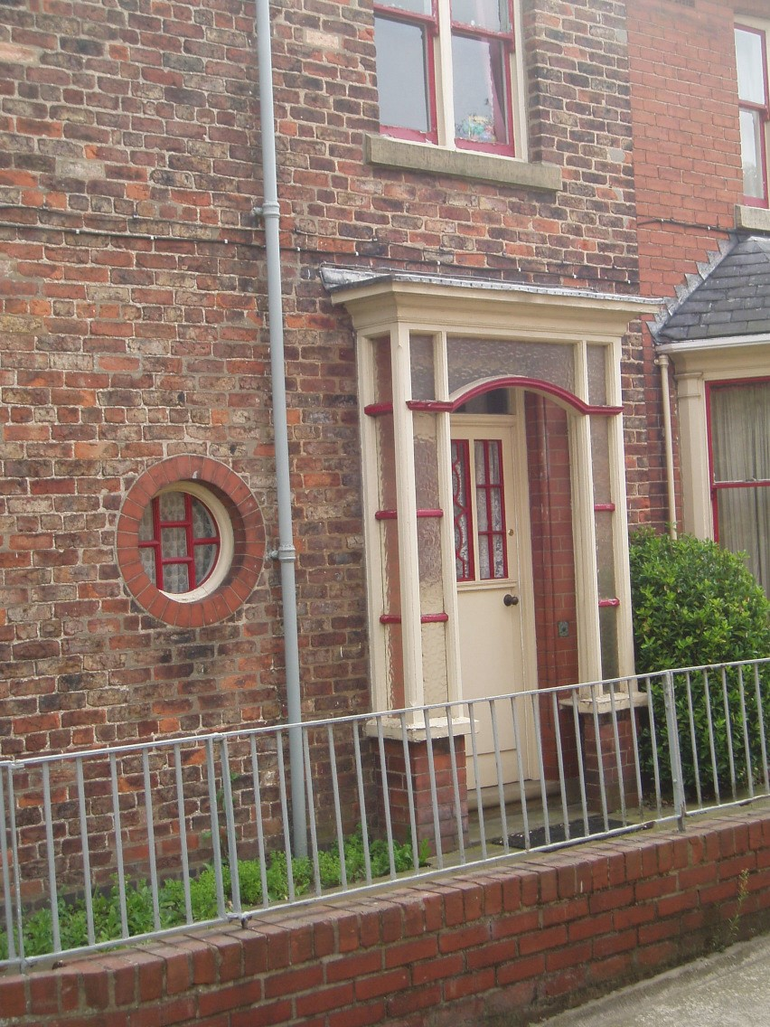
Characterful detailing on No.25 Front Street

In Pevsner’s Architectural Guide to York
& the East Riding, much of his description of Middleton is devoted to the late 19th century rebuilding works of the ashlar and slate-roofed church.

However, he does go on to describe the use of chalk-stone – a local material – and this material can still be seen in parts of the village.

iv) Walls

In spite of the proximity of chalk-stone, the dominant walling material in the village is brick. The general hue of these is red/brown, although there is the occasional example of the yellow/grey coloured brick called galt.

Several cottages have tumbled brickwork and raised verges to their gables. This is believed to relate to an era before the use of pan-tiles, when these roofs would have had straw thatch, the verges being built up to hold the straw in place and, by the bricks being on end, to protect the gables from the ingress of water The village also has its share of painted render and painted brick. These add variety to the streetscape and are in a range of shades from white through to cream and beige.

iii) Roofs
The predominant roofing material in the Conservation Area is the clay pantile, though this does not apply to the church, which is in slate. This may have been changed in the late 19th century, when much of the church was rebuilt. Also in terra cotta are French tiles – a generally flat tile with a single roll to the left-hand side which usually date from the early 20th century.

Slate can be found on various older buildings in the centre of Middleton, with some early 20th century houses using Rosemary (flat) tiles and those more recently built using concrete tiles.

A distinctive and unusual feature of Middleton’s building materials is the use of Wade Patent Interlocking Roof Tiles on South Street. These fish-scale shaped tiles were designed to better withstand displacement by storms. Manufactured in Hornsea at the end of the 19th century these then cost 35 shillings (£1.75) per thousand.

There are now only a handful of buildings left in the East Riding where these tiles can still be found.

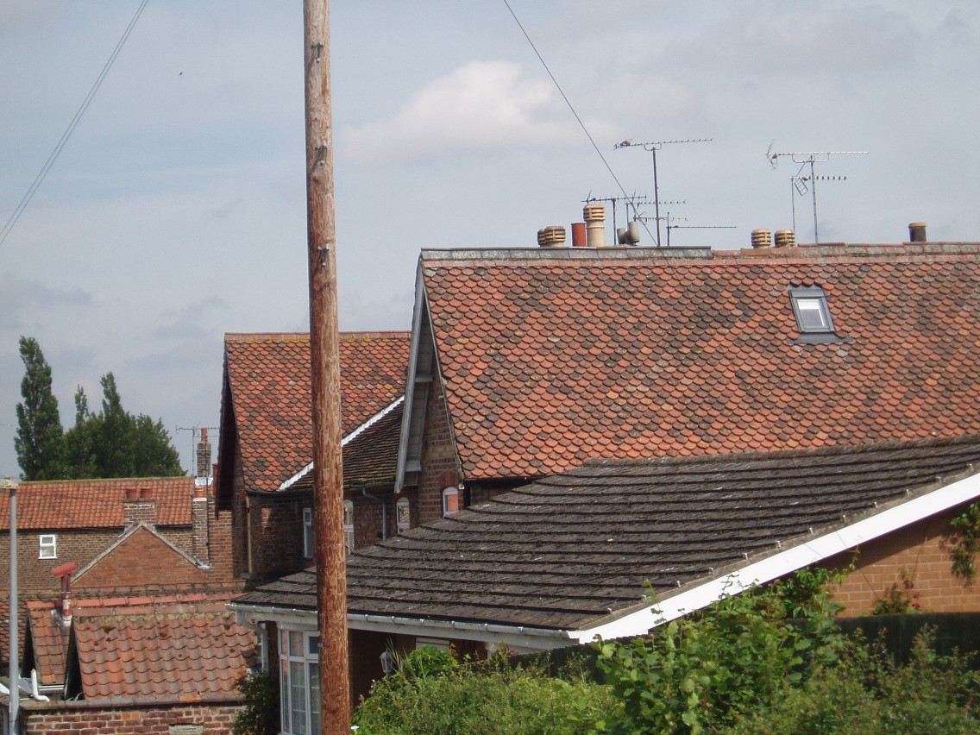
The Wade Tiles on Cottages in South Street

vi) Windows, Dormers, Doors & Porches

There have been lots of changes to doors and windows in the village, including the introduction of UPVC, particularly understandable where frontages are close to passing traffic.

On listed buildings these components are protected by legislation which disallows changes affecting these buildings’ special interest, unless they have prior consent. However, with unlisted buildings, changes of this nature do not usually need specific consent provided they relate to private dwellings that are not in commercial use. In such cases, what is important is to try to ensure that the historic styles and sections are replicated as closely as possible and in cases where this is achieved, the resultant change can be satisfactory without being visually disruptive.

There are however few remarkable examples of windows to comment on, though there are two on the South Street cottage, shown on page 7.

Rural East Riding villages are often typified by the use of dormers to provide additional accommodation in the roof space. Not so with Middleton where the most noticeable dormers (on South Street) are recent additions, as is the mock Tudor half-timbered effect which goes with them.

There are two examples of doorways which do much to enhance the character of their properties – these are at No 1 Church Hill Road, and a fine pair of front door and porch at 25 Front Street, shown on pages 9 & 10.
.
Both dating from the early years of the twentieth century, they exhibit the pride in craftsmanship that was the hallmark of that era.

Apart from this one, there are few porches in the historic parts of the village.

With timber items the paintwork in most properties is generally white or cream.

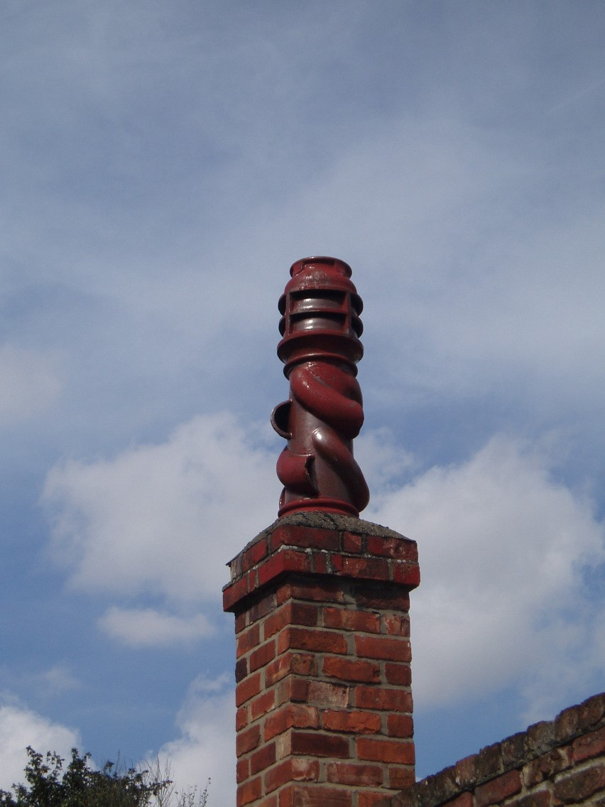
Characterful Glazed Chimney Pot in South
Street

With old buildings it is usually advisable to avoid brilliant white paint as this is a modern product which would therefore not have been available when they were built.
vii) Chimneys

Chimney stacks and chimney pots are important contributors to any village’s skyline, and Middleton is no exception to this.

The village benefits from a variety of chimney pots, both in terra cotta and cream colours, usually on ridge-mounted stacks. They come in various shapes and sizes, some being octagonal, some square and others round, most of them of a good height – 70cm or more – which adds to the impact they make.

k) Historic Buildings

Middleton on the Wolds was last reviewed for listing purposes in 1985. It has four listed buildings. With the exception of the Milestone, all of these are within the Conservation Area. They are:

St. Andrew’s Church II*

House c. 95 metres west of
Saint Andrew’s Church,
Front St (Quackers) II

Group of 4 Monuments about 15 metres south-east of St Andrew’s Church, Front
St II

Milestone (which is outside the Conservation Area), about 75 metres east of
East Field Farm, B1248 II

The principles of selection used by English Heritage for the listing of buildings seek to ensure that nearly all buildings before 1700, and most up to 1840 are listed. After this latter date there was a marked increase in the number of buildings erected nationally and therefore a significant decrease in the number of listings, with these being limited to the best examples of particular building types.

Most listed buildings (94%) are Grade II and classified as being of special architectural or historic interest, with Grade I being of exceptional interest and grade, II*, described as particularly important. St Andrew’s Church is one of these.

For further information on the above (listed) buildings, including their descriptions, please refer to www.imagesofengland.org.uk

- Focal Point Buildings

These buildings are highlighted because of the additional value that they have due to their location. Planning applications which relate to them will therefore be considered against the criterion that their design and detailing should reflect the importance of their location.

- Unlisted Buildings of Interest

The principles of selection for the listing of buildings, referred to under section jviii, increases the importance of Conservation Area designation as this gives additional protection to buildings of later date, that would not otherwise have it. In Middleton on the Wolds there are several buildings dating from the mid/late 19th century and up to the Great War, the loss of which would be particularly damaging to the character of the village and which could otherwise be demolished without the need for planning permission.

- Village Features

Like many other East Riding villages, Middleton still retains its Victorian letter box and its 1930’s red telephone box. Their colour ensures that they are eyecatching features within the village.

Also of historical interest are the mounting steps outside the Robin Hood Inn. These are becoming increasingly rare in the Riding.

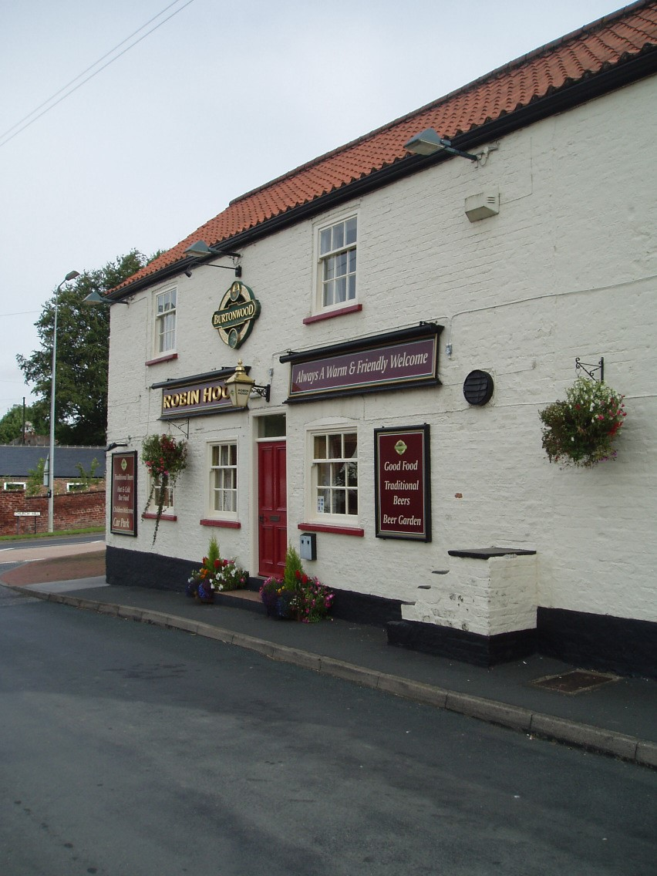
Mounting Steps at the Robin Hood Inn

***

POLICY STATEMENT FOR THE MIDDLETON ON THE
WOLDS CONSERVATION AREA

The East Riding of Yorkshire Council will use its powers to protect the special character of the Middleton on the Wolds Conservation Area.

The contrast between Front Street and South Street is referred to in the
Definition of Middleton’s special interest , and the Council will endeavour to ensure that these differences are maintained .

Where the removal of trees within the Conservation Area is approved, the Council will endeavour to ensure that the Area's long term character and appearance is not thereby damaged, and that, unless there are accepted reasons to the contrary, replacement planting is agreed and undertaken.

In the last paragraph of section (b) Natural Environment, the importance of its contribution is highlighted, and it will be council policy to ensure that this is protected and/or enhanced.

New Developments

The Council will give special regard to development proposals which may affect the Area and its setting, to ensure that it is thereby preserved or enhanced.

In the heart of the village is the former Stratstone Dealership site, which has recently been taken over as a retail outlet. This has had the benefit of tidying up what was formerly a derelict site. Its location in the middle of the village and at one of its focal points is very important to the character and appearance of the village as a whole, and were the development on the site to change, it is essential that such proposals should sit comfortably with the buildings around it and make a positive contribution to the character of the Area and its local distinctiveness.

The village has a shortage of high quality amenity space which may well have been caused by the alterations to the main thoroughfare to accommodate the volume of traffic passing through. Therefore any improvements to this situation would be a valuable enhancement to the
Conservation Area.

Recommended Materials

With repair works, where it is necessary to introduce new materials because those being replaced are no longer practical to re-use, materials should nearly always be the same as those which are removed.

With the materials for extensions and outbuildings, materials should usually reflect those of the ‘parent’ building.

For new build, materials that reflect the established character of the Conservation Area should be used. This would probably mean the use of a dark red brick, timber windows and doors, and pantiles or slates for the roof.

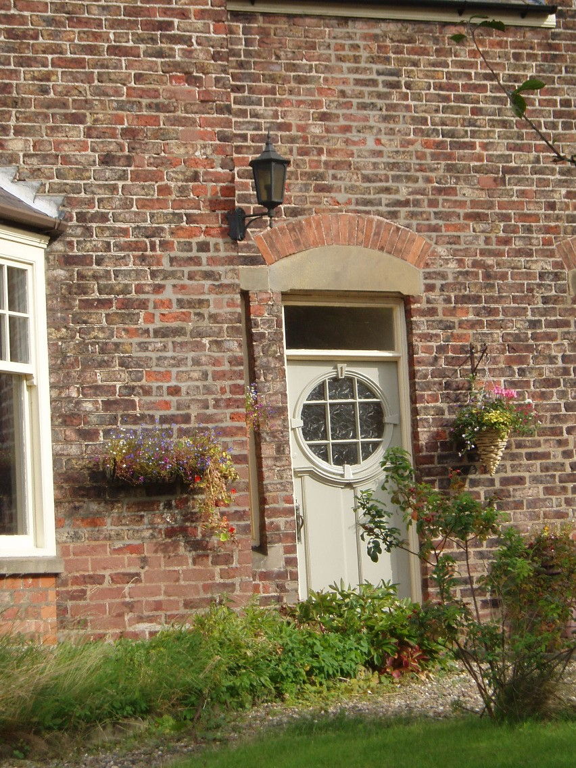
Early 20th Century Door with authentic door furniture

Where it proves impossible to match an existing brick, it is worth remembering that the second best option is to find a brick (of same size) which is darker in colour than those being matched, since it is the use of lighter bricks which normally looks more discordant.

***

COMMUNITY
INVOLVEMENT

Middleton on the Wolds Parish Council were made aware of the Council’s wish to designate a Conservation Area within the village and gave it their ‘in principle’ support. The residents of the village were also consulted. The comments received in the course of this consultation process were taken into account before the decision was taken to designate the Conservation Area.

PLANNING POLICY
CONTEXT

The principle legislation covering Conservation Areas is the Planning (Listed Buildings and Conservation Areas) Act 1990, which provides the framework for designation, review and appraisal of Conservation Areas.

There are also provisions within the Town & Country Planning Act 1990.

Government Policy and Guidance is set out in Planning Policy Statement 5, Planning for the Historic Environment, issued on behalf of the Department for Communities and Local Government by The Stationery Office. It is available online from:
http://www.communities.gov.uk/planningandb uilding/planning/planningpolicyguidance/planni ngpolicystatements/planningpolicystatements/p ps5/

Its sister document is PPS5 Planning for the Historic Environment: Historic Environment Planning Practice Guide, issued jointly by the Department for Communities and Local Government, English Heritage and the Department for Culture, Media and Sport. It is available from the Customer Services Department of English Heritage at:
customers@english-heritage.org.uk Both documents were issued in March 2010.

The planning policy affecting Conservation Areas within the East
Riding is set at the regional, sub-regional and local level. The Regional Spatial Strategy (RSS) for Yorkshire and the Humber (published May 2008) deals with the historic environment in Policy ENV9.

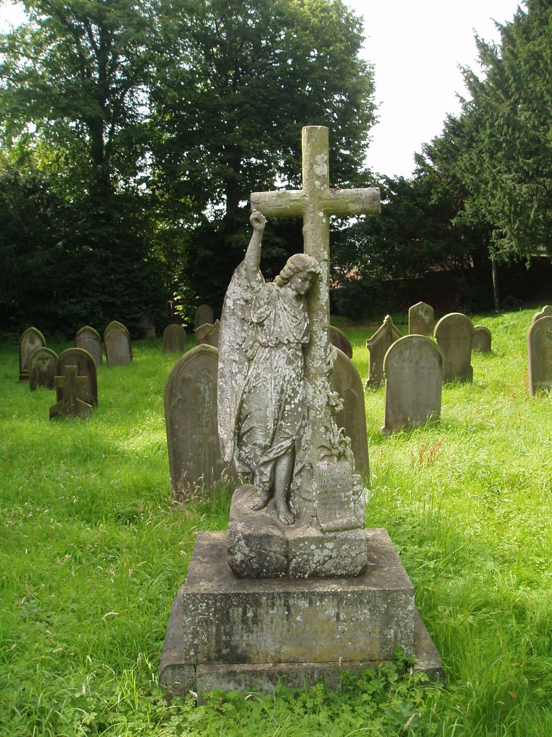
19th Century Monument in the Churchyard

This is developed at the sub-regional level by the Joint Structure Plan (JSP) for Kingston upon Hull and the East Riding of Yorkshire (adopted June 2005)in Policy ENV6.

At a local level, policies relevant to the
Middleton on the Wolds Conservation Area are currently contained in the East Yorkshire Borough Wide Local Plan
(adopted June 1997), Policy E19.
Other policies in this Plan can also affect the Conservation Area, including those dealing with new residential and commercial development, listed buildings and archaeology.

The JSP will be incorporated into the Local Development Framework (LDF), which will also supersede the current Local Plan in due course. This appraisal will be used as a background document in support of the relevant LDF
Development Plan Document and as a material planning consideration in the determination of relevant planning applications.

LOCAL GENERIC GUIDANCE

East Yorkshire Borough Wide Local Plan, Policy E19.

Leaflet,” What are Conservation Areas?” by East Riding of Yorkshire Council, Customer Services, County Hall, Beverley,
HU17 9BA

USEFUL INFORMATION AND CONTACTS

Conservation Team, East Riding of Yorkshire, County Hall, Beverley, HU17
9BA

E-mail address: conservation.and.enforcement@ eastriding.gov.uk

This appraisal was undertaken with information provided by Humber
Archaeology Partnership and specialist officers of the Council.

It has been written in accordance with “Guidance on Conservation Areas” issued by English Heritage in August 2005.

Residents consulted on this appraisal were those whose addresses appeared on the unedited Register of Electors for 2009.

The photographs used in this document were taken in Summer 2009.

For information on other East Riding Conservation Area appraisals, please search for ‘Conservation Area Appraisals’ on the Council’s website, www.eastriding.gov.uk under Environment and Planning, where those that have recent appraisals can be found.

APPRAISAL AVAILABILITY

The draft document was made available on-line for the benefit of residents of the Area, Middleton on the Wolds Parish Council and other interested parties during the consultation period.

Information on this and other East Riding Conservation Areas can be found under ‘Conservation Area Appraisals’ on the Council’s website: www.eastriding.gov.uk

(At this date more than 90% of the Council’s Conservation Areas have upto-date appraisals.)

The Middleton on the Wolds
Conservation Area was designated, and this appraisal was adopted, on
6th April 2011.

