A MEETING OF MIDDLETON-ON-THE-WOLDS PARISH COUNCIL WILL BE HELD

ON MONDAY 22nd MARCH 2021
This will be a remote meeting via Zoom and the link may be found on the parish council web site or by contacting the clerk on pc@middletononthewolds.co.uk
THIS IS AN OPEN MEEITNG AND MEMEBERS OF THE PRESS AND PULIC ARE WELCOME TO ATTEND.
The Business to be transacted is shown below:

AGENDA
1. To receive Apologies

2. To receive Declarations of Interest (Code of Conduct 2012)
- Pecuniary
- Non- Pecuniary Interests
- Dispensations issued

3. To discuss and agree on comments to Planning Application 21/00414/TCA
Proposal: Remove 1 no Conifer tree (T1) due to tree being ugly and misshapen. Crown reduce 1 no black Cherry Plum tree (T2) by 2 mtrs and remove 1 no side branch growing towards the road in order to improve shape and restrict ultimate height Location: 44 South St, Middleton on the Wolds Y025 9UB

Applicant: Mr Glen Kenworthy
Application Type: Tree Works in a Conservation area
- 4. To approve appointment and remit of a sub committee consisting of Cllrs D Carlin, J
Fisher, T Walker and P Roe to oversee the plans for the Recreation Ground play equipment.
- To approve and formally authorise the clerk Sandra Morrison to sign funding agreements on behalf of the Parish Council in relation to funding applications for the Recreation Ground Play Equipment

6. To discuss and agree on next steps re traffic issues and responses from ERYC

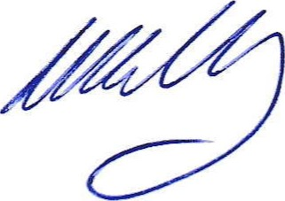
Signed
Chairman 